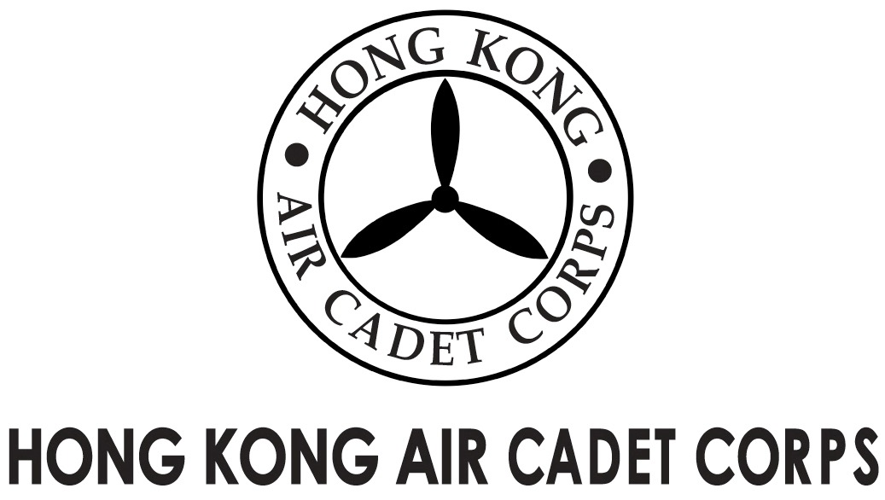
ADMINISTRATION AND SUPPORT GROUP.

From | OC PA Flt  Saki L W LEE  (sakilee0906@gmail.com) | To  Copy to | OC No. 103, No. 308  Major Unit Commanders
Our Ref | GOSA/2017/3 | # of Pages | 1
Date | 4-Dec-2017 | Your Ref

Grantham Uniformed Youth Groups Outstanding Service Award
葛量洪青少年制服團隊傑出服務獎
Invitation for Interviews

Please take note that the following cadets nominated for the caption award are invited to attend an interview at Josey Room of Aviation Club on 09-Dec-2017 (Saturday).

Rank and Name Interview Time
Cadet Sergeant HO Ho-yin 1000 – 1015 hrs
Cadet Sergeant FUNG Chi-wai 1015 – 1030 hrs

The dress code is No.2A or 2B. Please report to the venue 10 minutes before your allotted time.

Yours sincerely,

Saki L W LEE
Flying Officer OC PA Flt

